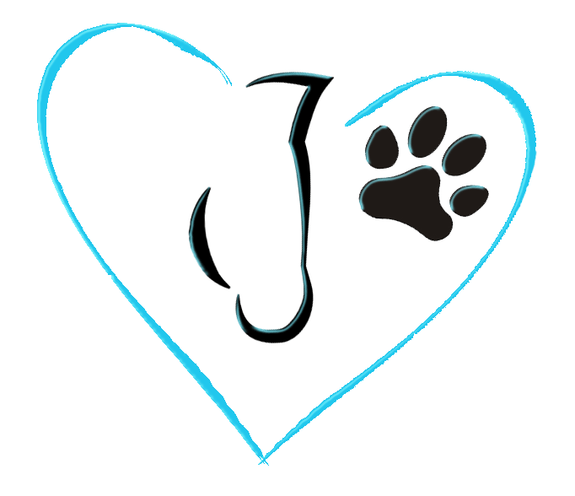
Knaughty Nets & Pets

Home of the Happy, Healthy Horse & Hound

Knaughty Nets & Pets are always on lookout for “Knaughty” athletes to be on our team!! We are looking for Equine/Canine and Human athletes striving for The Happy, Healthy Horse & Hound!!

DUE: April 1st, 2018

Completed forms may be submitted: By Email: knaughtynetsandpets@hotmail.com
By Mail: Sponsor Program-Knaughty Nets & Pets
RR 1 Site 12 Comp 16
Millet, AB, T0C 1Z0

CONTACT INFORMTION:

Name:____________________________________________________________________________________

Address:___________________________________________________________________________________

Phone Number:_____________________________________________________________________________

Email Address:______________________________________________________________________________

CHECK DISCIPLINE(S):

Jumping/Eventing/Dressage Cutting/Team Penning/Sorting

English/Western Pleasure Mounted Shooting

Trail Riding Draft Horse Showing

Rodeo/Barrel Racing Driving

Reining Other_____________________

Dog Showing/Conformation Rally/Obedience

Agility Nose Work

ANSEWER THE QUESTIONS BELOW: (Tell us about yourself, the more the better)

- Do you compete?
- Are you a member of any clubs/associations/groups?
- What are your goals/ dreams with your Equine or Canine Athlete?
- My 2018 goals are?
- When did you start?
- Why do you do what you are doing?

Please attach a photo of you and your athlete(s).

WHAT DOES THE SPONSORSHIP INCLUDE?

- 250 personalized business card with a discount coupon attached to give out.
- Knaughty Nets & Pets Team Jacket
- Knaughty Nets & Pets Hat and Mug
- $300 worth of Knaughty Nets Products
- 25% Discount off Knaughty Nets & Pets products for the year sponsored

REQUIRMENTS:

- Must use and promote Knaughty Nets & Pets products
- Must wear and use Knaughty Nets & Pets products/gear during competition/riding/etc.
- Knaughty Nets & Pets has the right to share your photos and story on our website and any of our social media sites as well as any other information you send us. (we will not share personal contact information)
- Must post on Social Media 2x per month
- One video post with Knaughty Nets

Please sign agreeing to these requirements above:

Name:___________________________________________ Date:____________________________________

Signature of parent/legal guardian if under 18:

Name:___________________________________________ Date:____________________________________

